* document.getElementById:

document.getElementById(“ID”)

* document. getElementsByTagName(“Tag_Name”):

document.getElementsByTagName(“p”) -> return list which can be access using index

document.getElementsByTagName(“*”) -> returns all tags in document

document.body.getElementsbyTagName(“* or etc”)

More Specific:

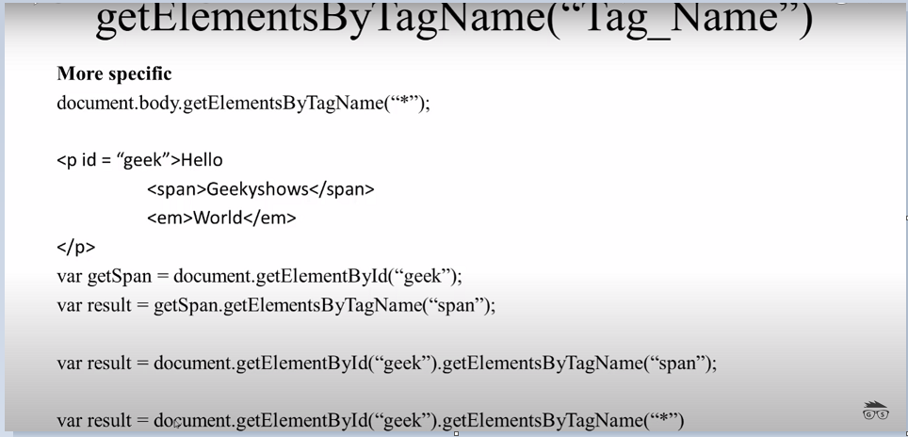

Length attribute:

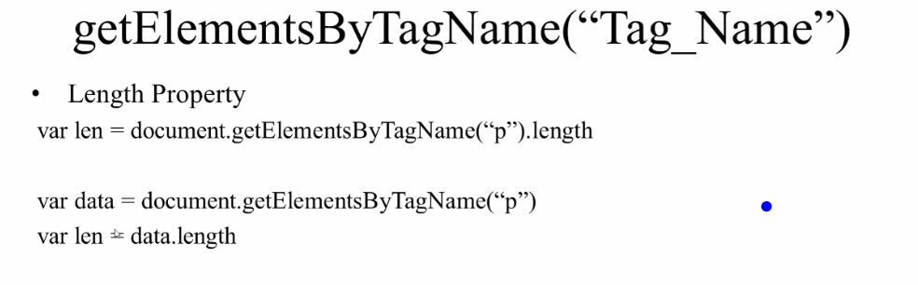

For loop:

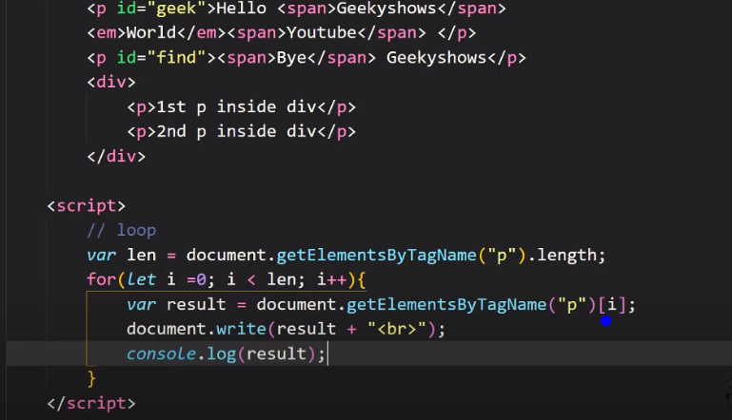

* document. getElementsByClassName(“ClassName”):

document. getElementsByClassName(“ClassName”) -> again returns list access by index

More Specific

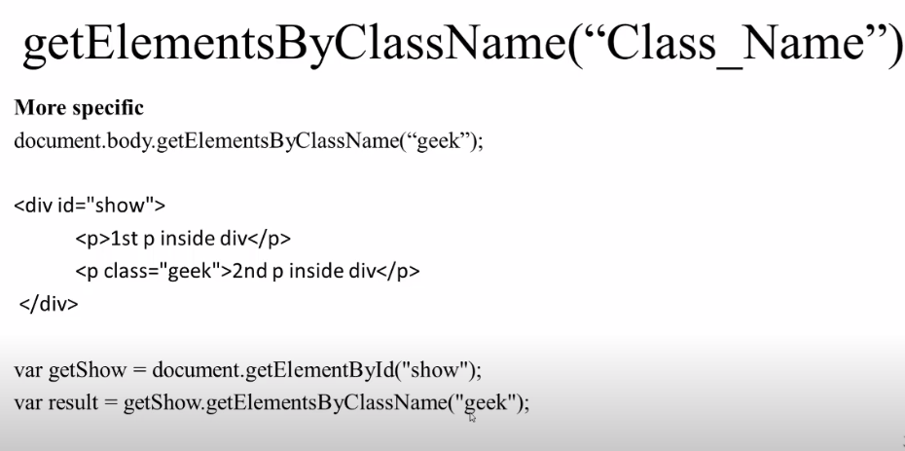

For Length:

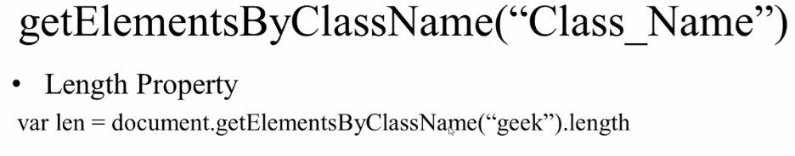

For Loop:

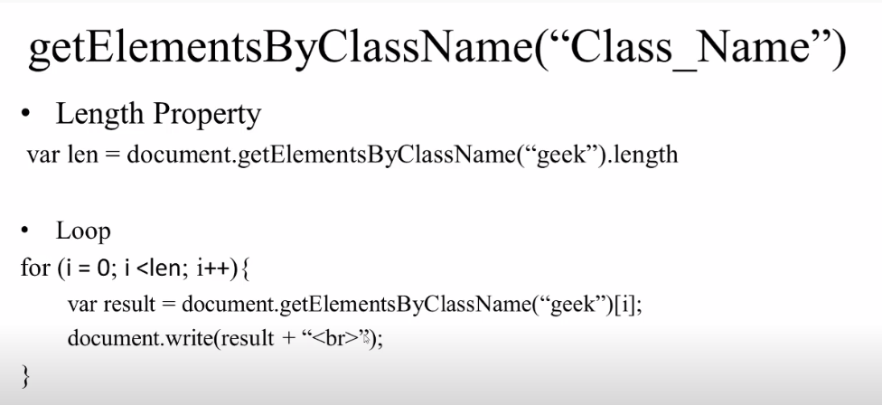

* querySelector(“single return”):

Returns only first matched value, not all. First come first get, whether we pass multiple values separated by comma or single, it returns only first value it sees In the code. For all, we use querySelectorAll

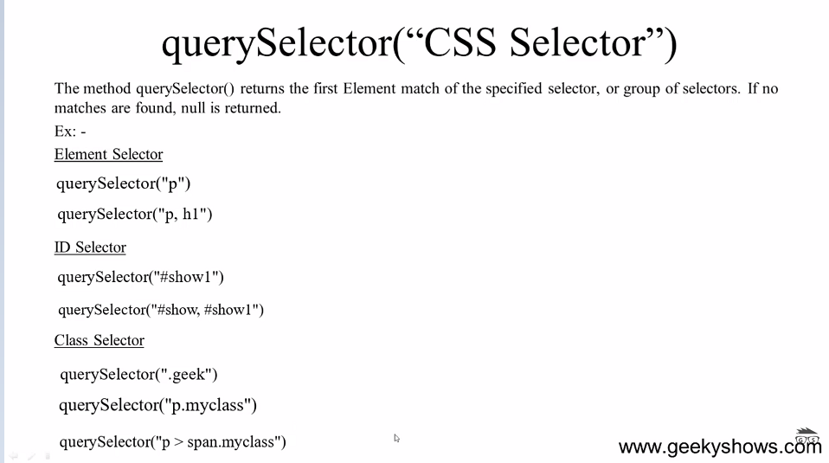

Multiple selection should be separated by comma, like if querySelector(“p, h1”), it returns first element in code only, like if h1 earlier before p, then it returns only h1 and ignore p

querySelector(“p.myclass”) -> returns tag of myclass in p tag

* querySelectorAll(“multiple returns”):

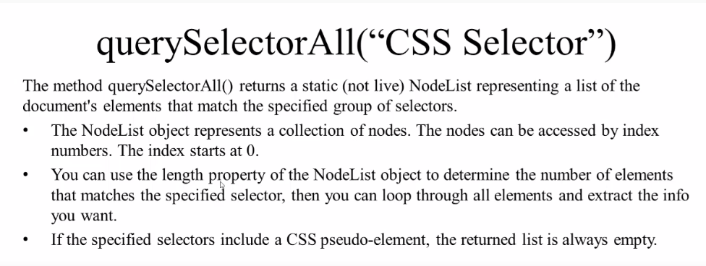

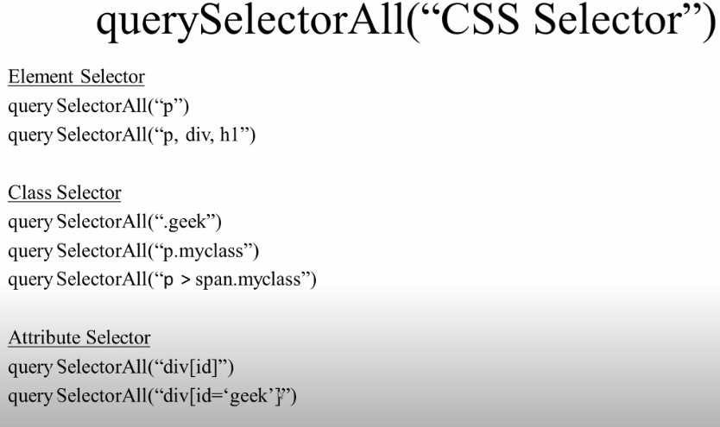

querySelectorAll(“div[id[“) -> returns all that div which has attribute id

More Specific:

Find id show and then span tag with class myspan

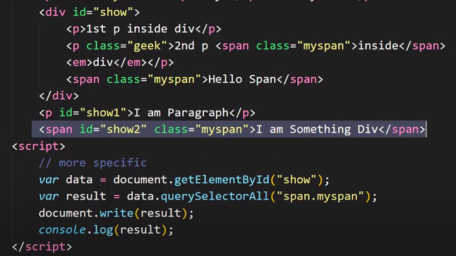

Another way:

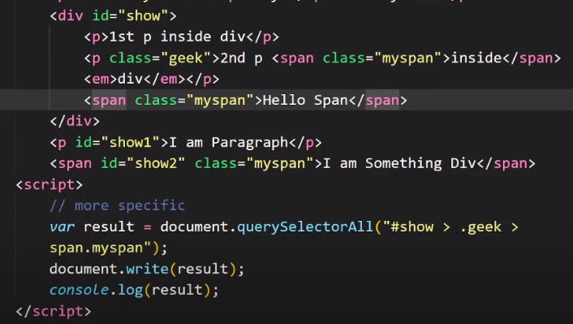

For Loop:

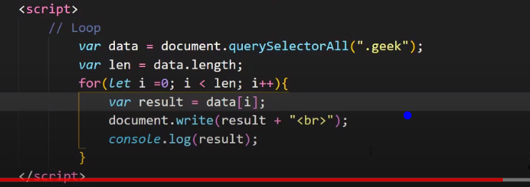

* WebPage Properties:

In console of any website, write

Console.dir(document) -> it will return all properties(like url, domain title etc) use in that website

Then from that, we can access each property separately in VS or console as;

document.title or document.domain

(In VS -> under script write, console.log(document.title) )

And we can also update those properties in js, like we can change title of website as

document.title = “Update title”

* Node Object:

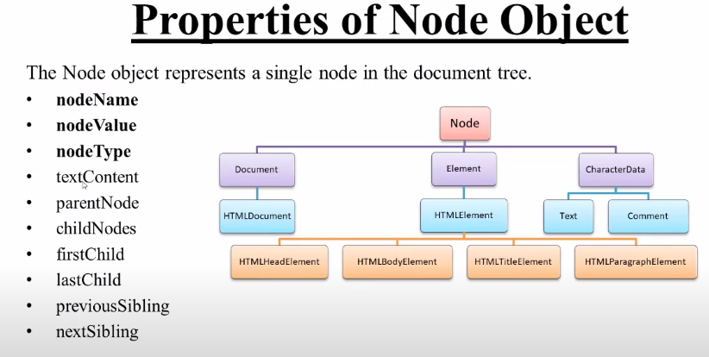

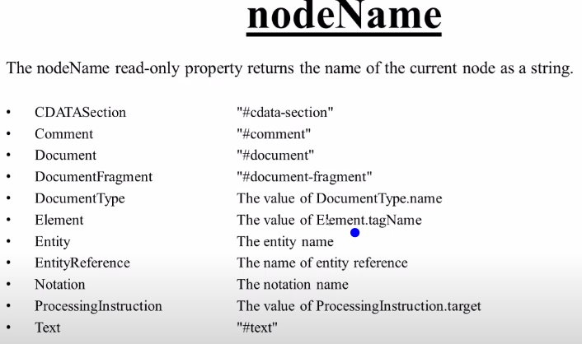

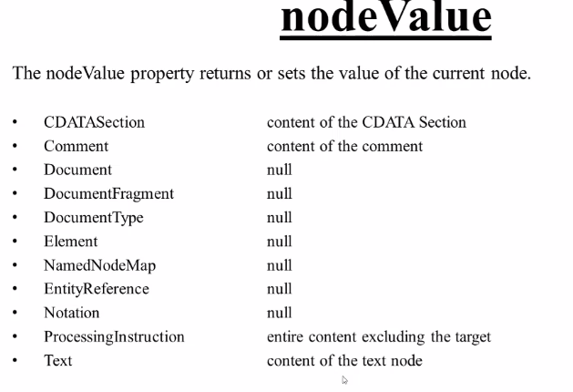

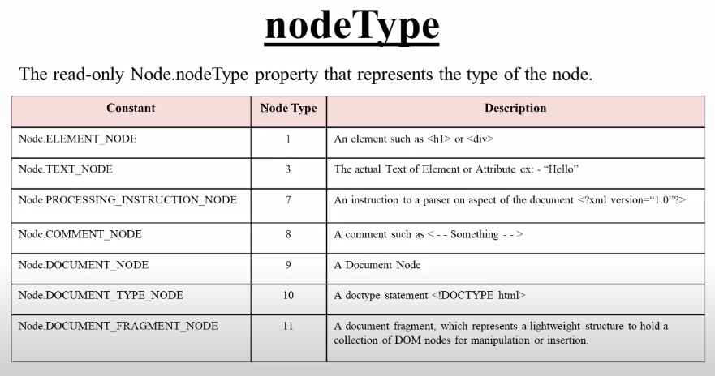

Attributes property in JS:

Name.attributes -> returns all attributes in a tag

We can then access them using list indexing or key value pair

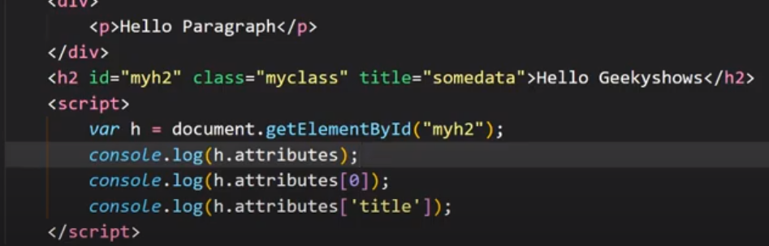

* Set Attribute:

It updates value of given attribute of an element if it is already exist or create new attribute with the provided value if not exist. Remember It will overwrite the previous values of the provided attribute

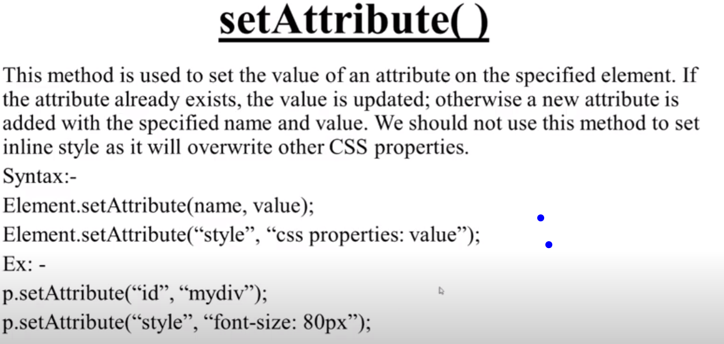

p.setAttribute(“id”,”mydiv”) -> set id=”mydiv” of p element or p tag

* get attribute

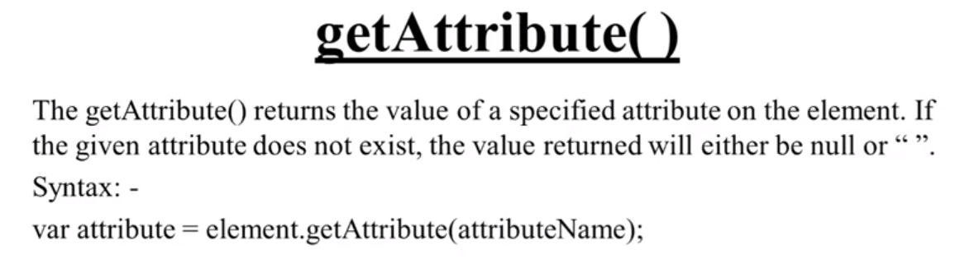

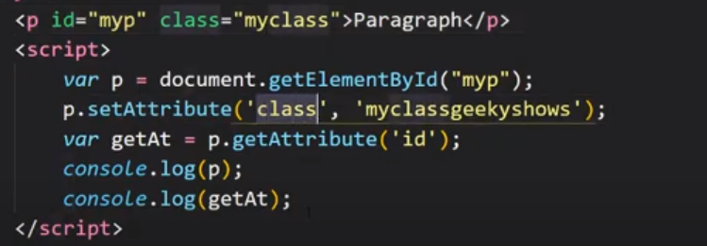

Other method of setting attribute:

Like if we want to set a class then;

p.className = “myclassgeekyshows”

document.getElementbyId(“myp”).className or .title etc

and similarly getting an id can be;

console.log(p.id)

* remove Attibute:

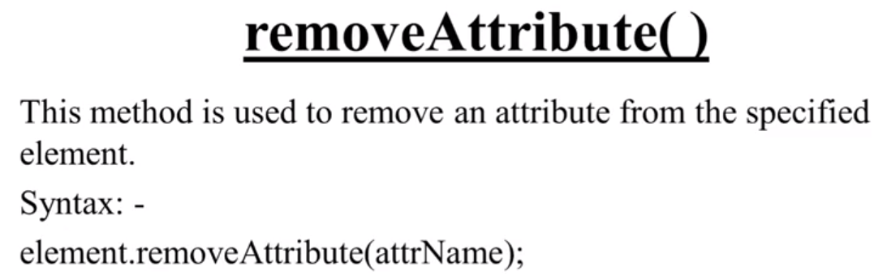

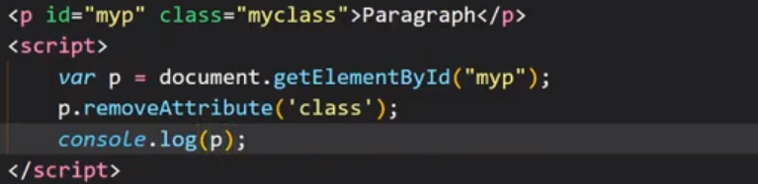

* Has Attribute:

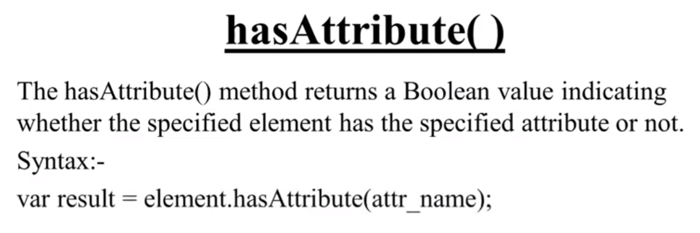

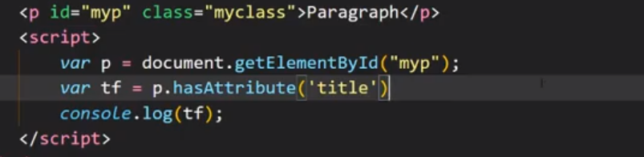

* HTML ATTRIBUTE Vs DOM PROPERTY:

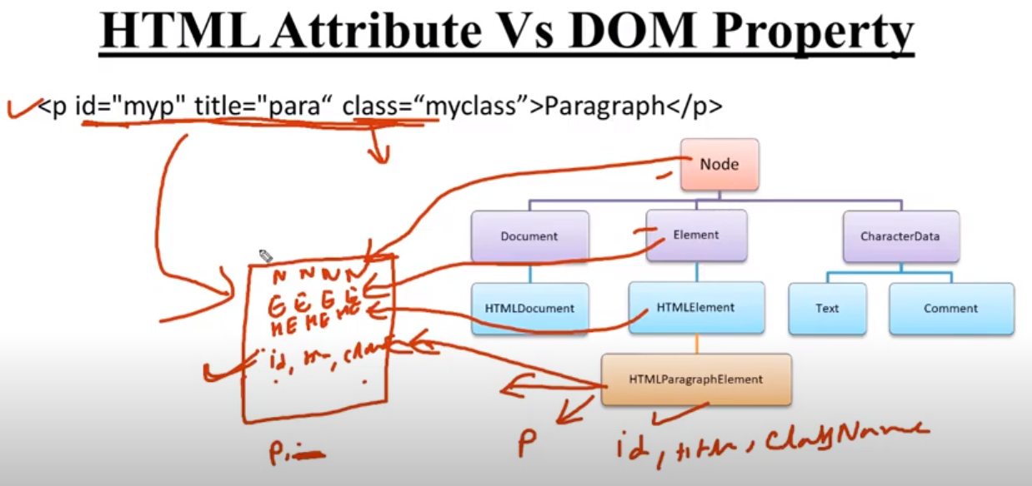

Like class is html attribute, but in dom, it is className and we used DOM in js, that’s why we used className in js

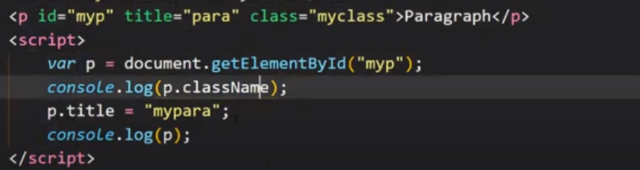

In script, we can write p.title or p.id but we cannot write p.class as it not supported in DOM, we have to write p.className

* HTML DOM MAPPING:

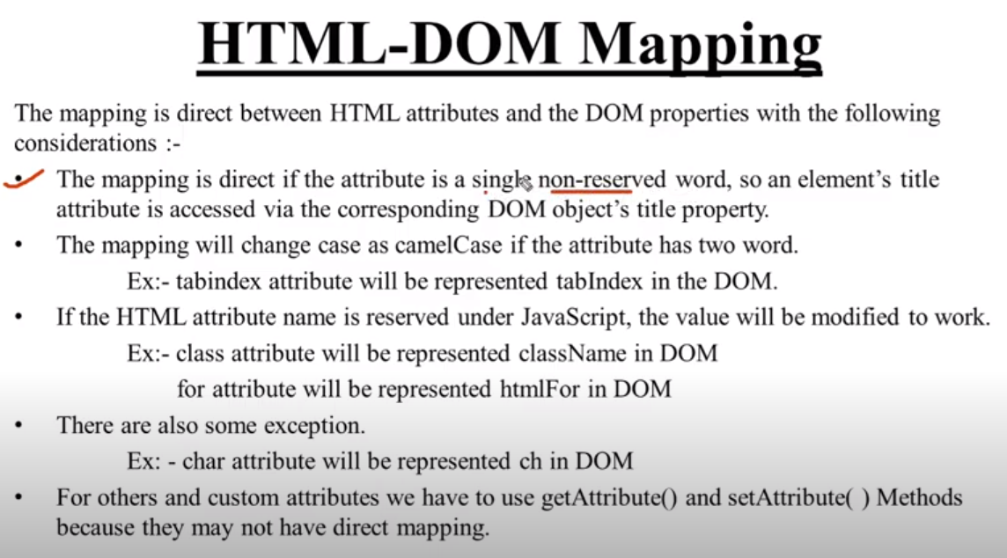

Example of first bullet -> document.getElementbyId(“id”).title or .class

* CSS DOM MAPPING:

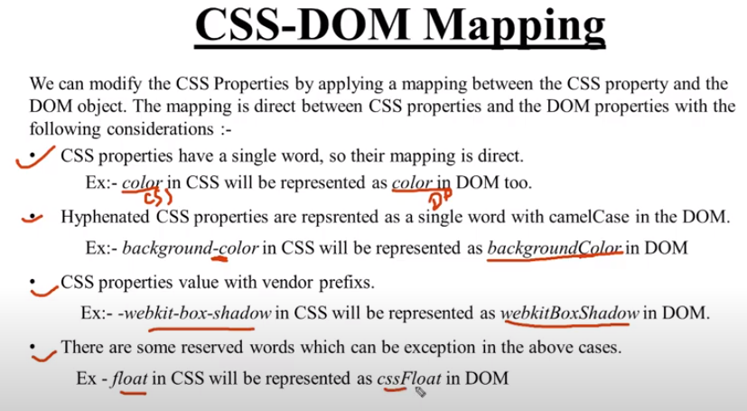

CSS Style Declaration Object:

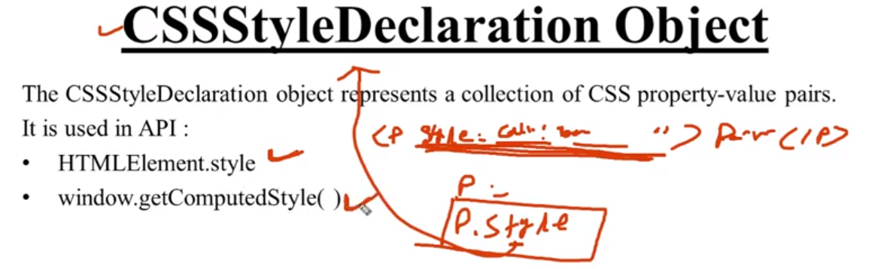

It is only used with inline Css

We used style property with element

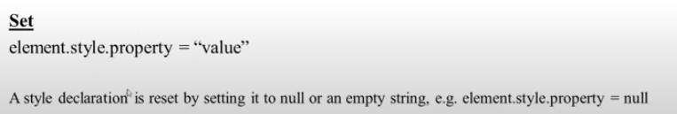

Example:

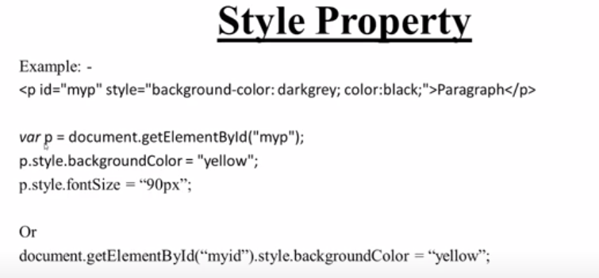

Remember, in js we use dom property instead of HTML attribute, that’s why used backgroundColor instead of background-color

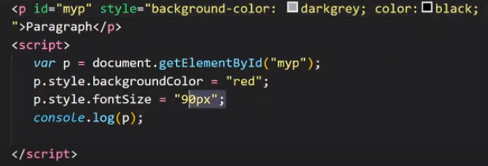

Hurdle in style property is that we can modify single style property at a time

DYNAMIC STYLE MANIPULATION:

